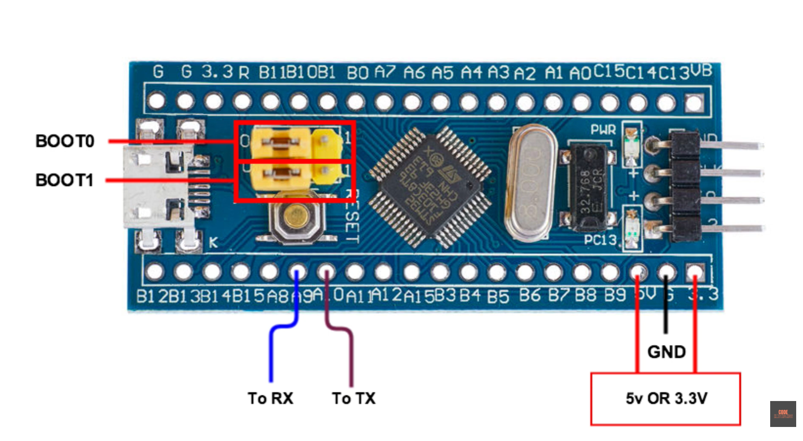
TTL connector
USB to TX to STM32 PA10
USB RX to STM32 PA9
USB GND to STM32 GND
USB 3.3V to STM32 3.3v

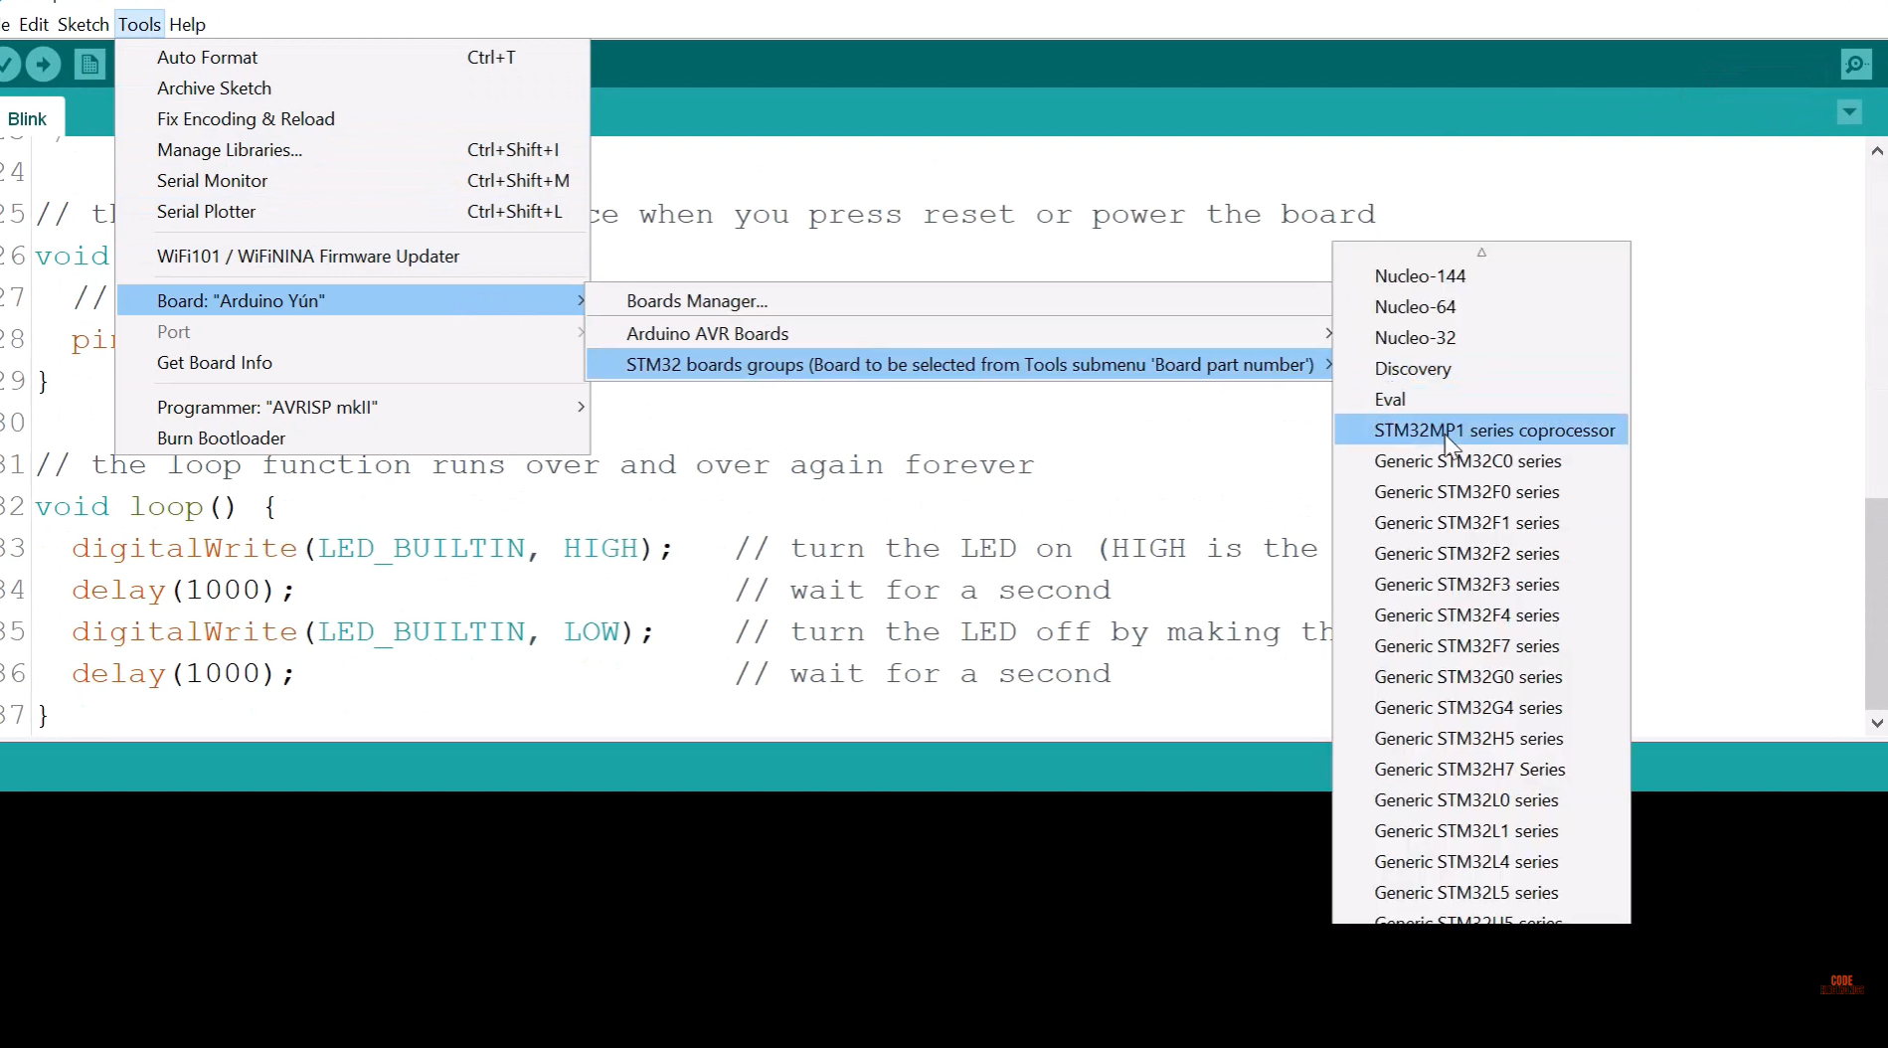
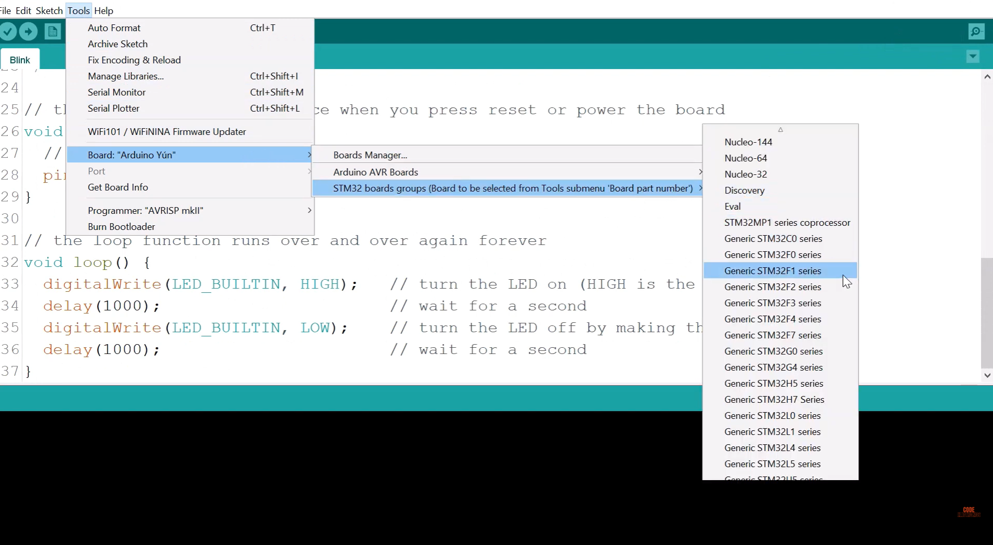

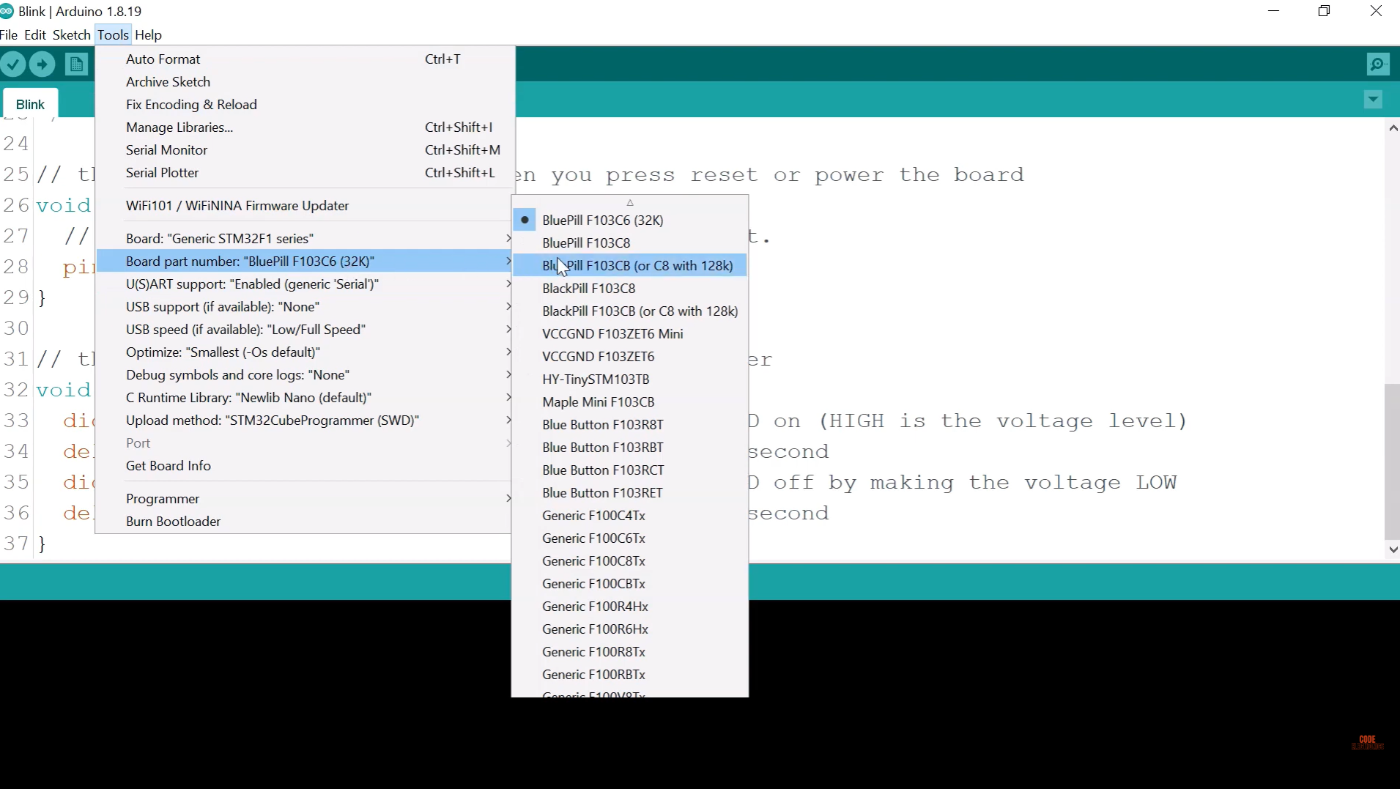

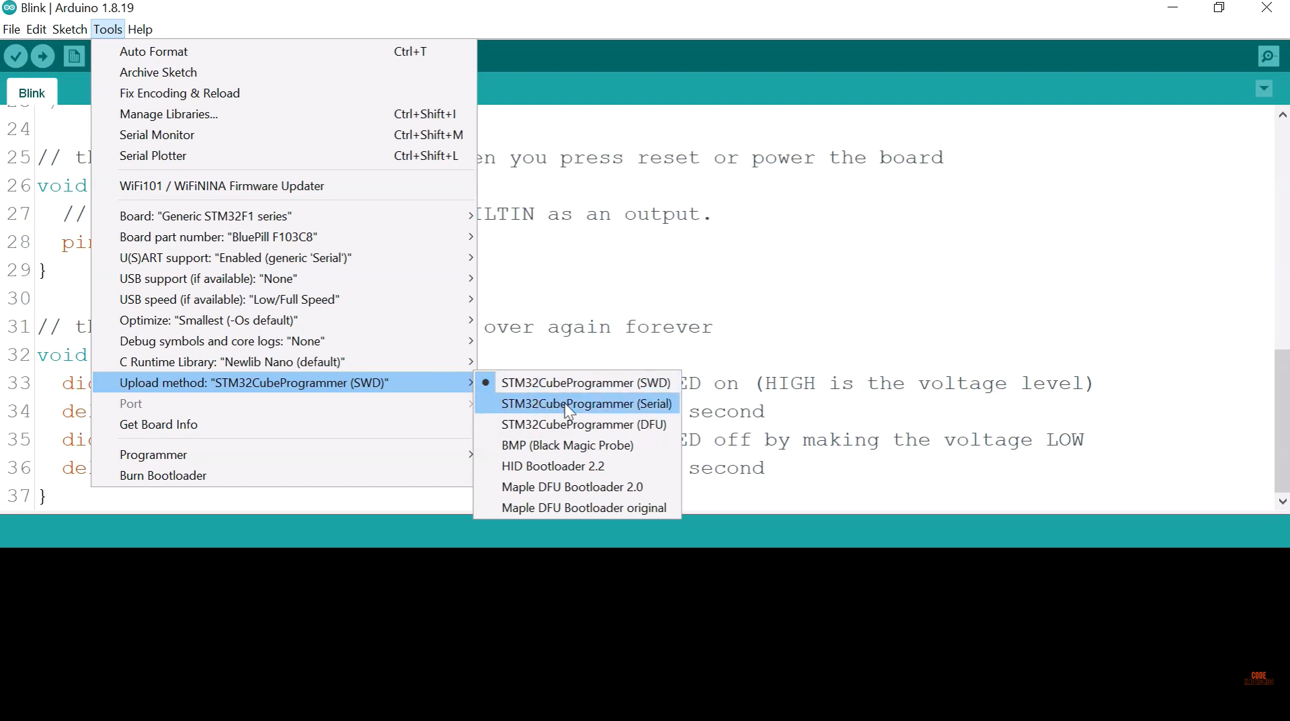

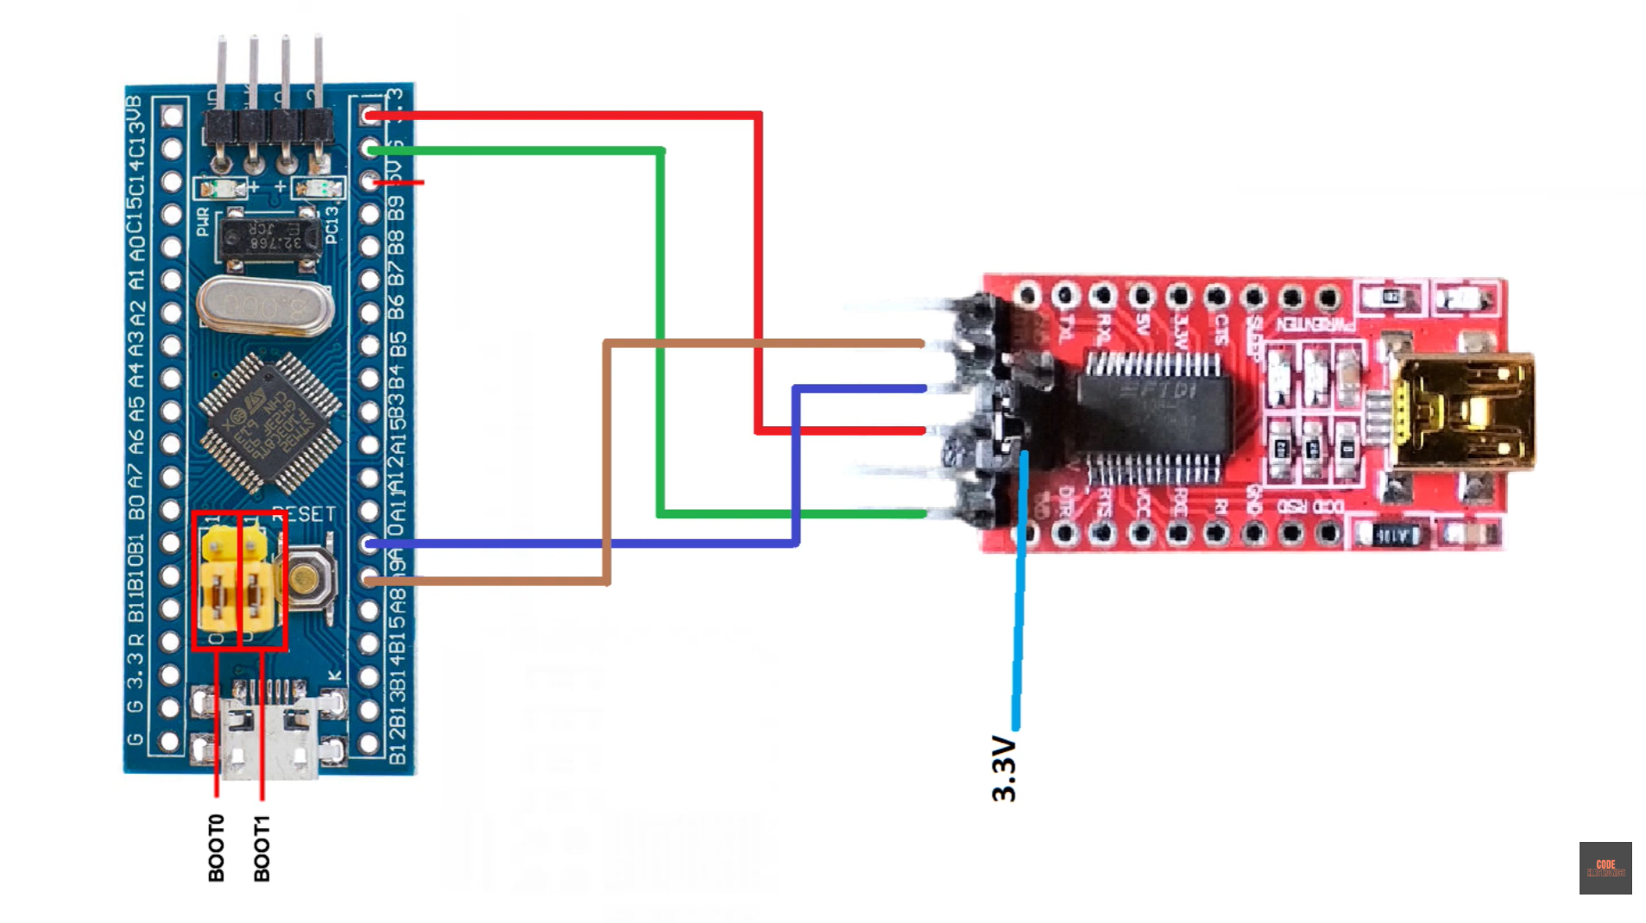

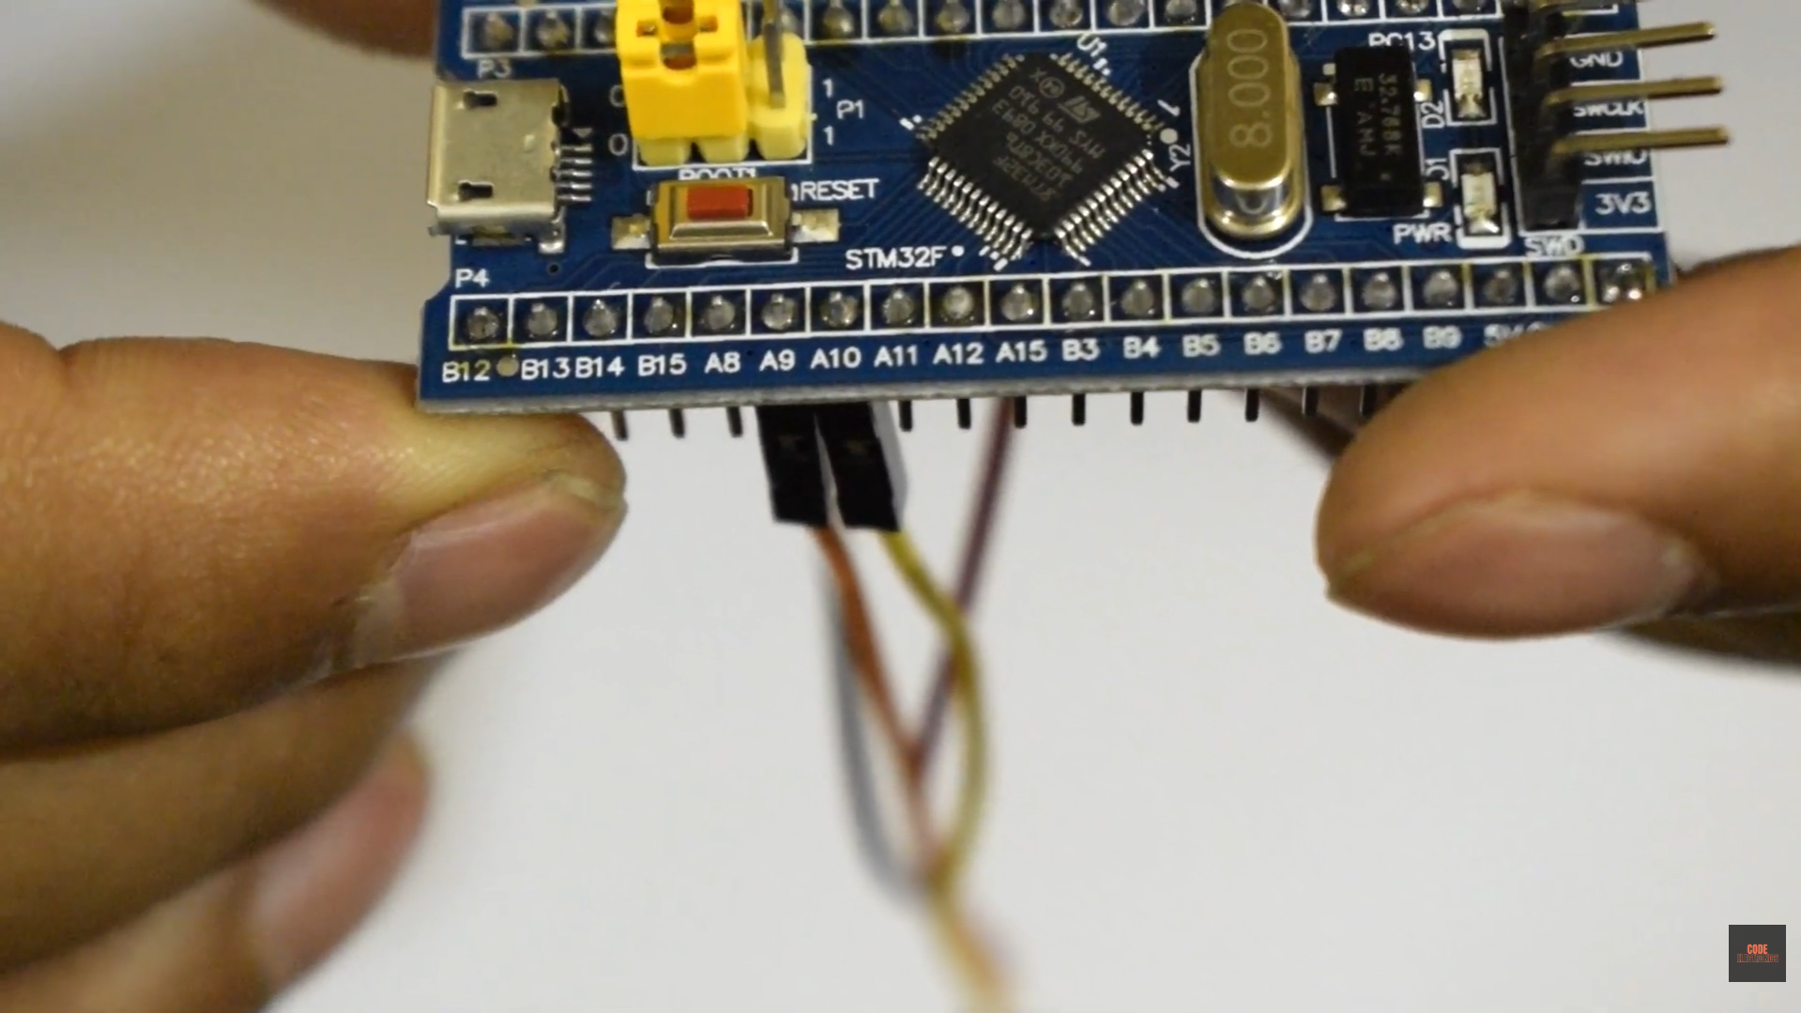

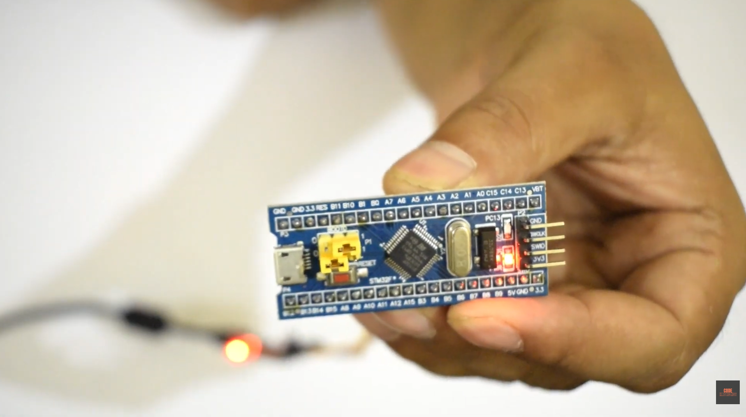

- Microcontroller: STM32F103C8T6
- CPU: ARM Cortex-M3 (32-bit)
- Frequency: 72 MHz
- Flash Memory: 64 KB
- SRAM: 20 KB
- Operating Voltage: 2.0V to 3.6V
- GPIO: 37 pins
- Analog Pins: 10 (12-bit ADC)
- Peripherals:
  - 3 x USART
  - 2 x I2C
  - 2 x SPI
  - 1 x CAN 2.0
  - USB 2.0 full-speed
- Debug: SWD (Serial Wire Debug) support
- Onboard Connector: Micro USB

Advantages over ESP32
While the ESP32 is a powerful and affordable board with built-in Wi-Fi and Bluetooth, the Blue Pill excels in applications requiring more precise, reliable, and non-wireless performance.
- Real-time performance: The STM32's ARM Cortex-M core is better suited for applications that demand high-speed, predictable, and precise responses, such as motor control, industrial automation, and robotics. The ESP32's dual-core design is optimized for multitasking but can have timing issues due to its overhead for managing Wi-Fi and Bluetooth stacks.
- Power efficiency: For projects that need to run for extended periods on a battery, the STM32's low-power modes offer a significant advantage over the ESP32, which consumes more power when its radio is active.
- Rich and dedicated peripherals: The Blue Pill offers a wider and more flexible set of dedicated peripherals, including more UART, SPI, I2C, and more advanced timers. In contrast, many of the ESP32's pins have multiple functions that can limit concurrent usage.
- Industrial-grade robustness: STM32 microcontrollers are designed for high-reliability, mission-critical applications in harsh environments, such as factory equipment and automotive systems. The ESP32 is generally built for consumer IoT devices.

Advantages over Arduino Uno
Compared to the beginner-friendly Arduino Uno, the STM32 Blue Pill is a more powerful and professional-grade alternative for users ready to take on more complex projects.
- Significantly higher performance: The Blue Pill features a 32-bit ARM Cortex-M3 processor clocked at 72MHz, vastly outperforming the Arduino Uno's 8-bit ATmega328P processor running at 16MHz.
- More memory: The Blue Pill offers substantially more flash memory (64/128KB) and SRAM (20KB) than the Uno's 32KB of flash and 2KB of SRAM, allowing for more complex programs and greater data storage.
- More and better peripherals: The Blue Pill has more GPIO pins, more UART, SPI, and I2C ports, and a higher resolution ADC (12-bit vs. 10-bit) for more precise analog readings.
- Lower cost for performance: Despite its superior capabilities, the Blue Pill is typically less expensive than a genuine Arduino Uno, making it a very cost-effective choice for hobbyists and professionals.

When to choose each board

When to choose each board
To decide which board is right for your project, consider the following trade-offs:
Feature | STM32 "Blue Pill" | ESP32 | Arduino Uno
Best for | High-performance, low-power projects requiring precision control, extensive I/O, or advanced timing. | Internet of Things (IoT) applications that require integrated Wi-Fi and Bluetooth. | Beginners, educational purposes, and simple projects where ease of use is the top priority.
Performance | High-speed (72MHz), 32-bit ARM processor and more memory for complex tasks. | High-speed (240MHz dual-core) processing, good for multitasking, but less deterministic for real-time applications. | Basic (16MHz), 8-bit processing, limited for complex calculations or high-speed tasks.
Wireless | No built-in wireless, requires external modules. | Built-in Wi-Fi and Bluetooth connectivity. | No built-in wireless.
Power Use | Excellent for ultra-low-power designs and battery-powered devices. | Good for short bursts of wireless communication, but higher power consumption in active mode. | Moderate, suitable for basic projects but not designed for ultra-low-power consumption.
Ease of Use | Moderate to difficult. Steeper learning curve requiring external programmers and more complex development tools like STM32CubeIDE. | Easy to moderate. Strong Arduino IDE support and large community for rapid prototyping. | Very easy. Large community, abundant libraries, and simple IDE make it the easiest to learn.
Cost | Very affordable, offers high performance for the price. | Very affordable, especially considering the integrated wireless features. | Generally affordable, though more expensive relative to its capabilities

http://dan.drown.org/stm32duino/package_STM32duino_index.json

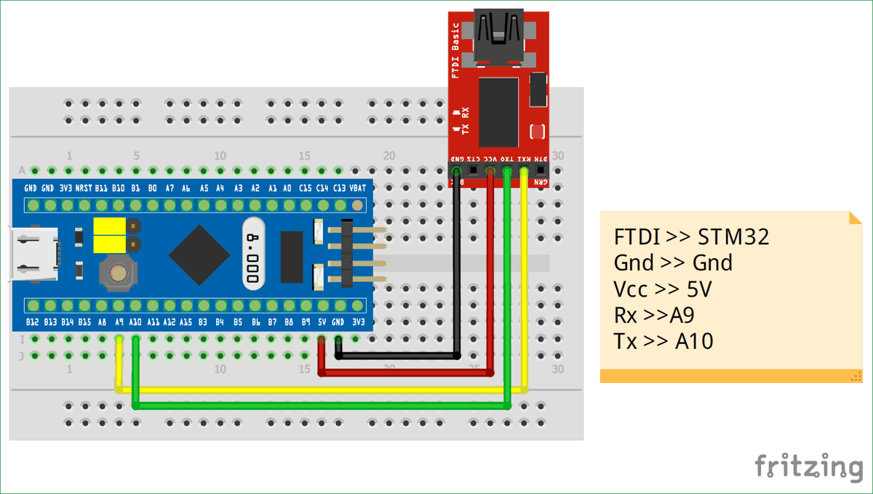

/*
circuitdigest.com
Sample STM32 Blink Program for Blue Pill board
*/
// the setup function runs once when you press reset or power the board
void setup() {
// initialize digital pin PC13 as an output.
pinMode(PC13, OUTPUT);
}
// the loop function runs over and over again forever
void loop() {
digitalWrite(PC13, HIGH); // turn the LED on (HIGH is the voltage level)
delay(1000); // wait for a second
digitalWrite(PC13, LOW); // turn the LED off by making the voltage LOW
delay(1000); // wait for a second
}

